

Working schemata of the Hyprex pressurewave charger

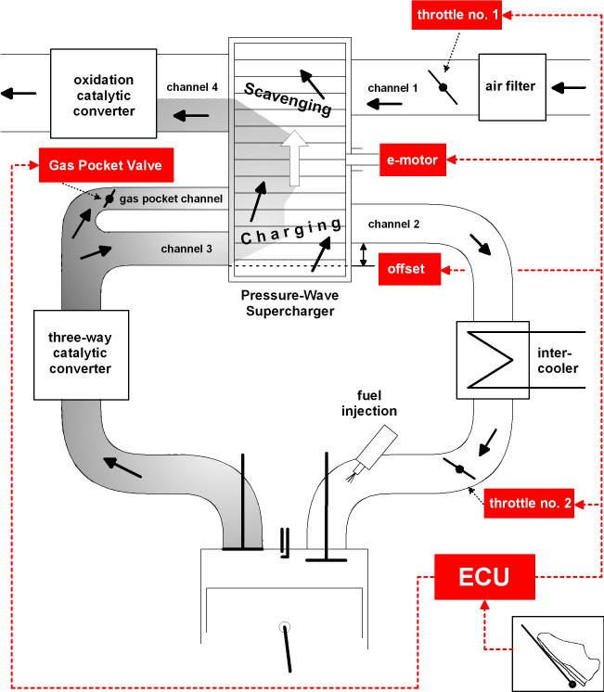

- The picture shows the pressure wave process unwinded, on which the continuous through going rotor cells are always opened and closed in the right moment by using gas dynamic effects. For this the rotor cells are running over so called control edges in the casing on the exhaust and on the air side.
- The Primary Pressure Wave generates by the exhaust gas compresses the fresh Air in the Rotor Cells, in the moment the rotating cell is given free by the casing.
- The Pressure Difference between Port 2 and the Rotor Cells induces a Secondary Pressure Wave travelling back through the Rotor
- An Expansion Wave slows down the Cell Content and decreases the Pressure in the Rotor Cells
- While opening the rotor cell at channel 1 a strong Expansion Wave is generated and evacuates the Cells, purging them with Fresh Air
- Since Pressure Waves are faster than the flowing Medium, Mixing of Exhaust and Fresh Air can be avoided, by using always the correct rotor speed and offset.

